Student Name: _________________________________ Date: ___________

Instructor Signature:_________________________________ Date: ___________

Point Assignment: ________________________
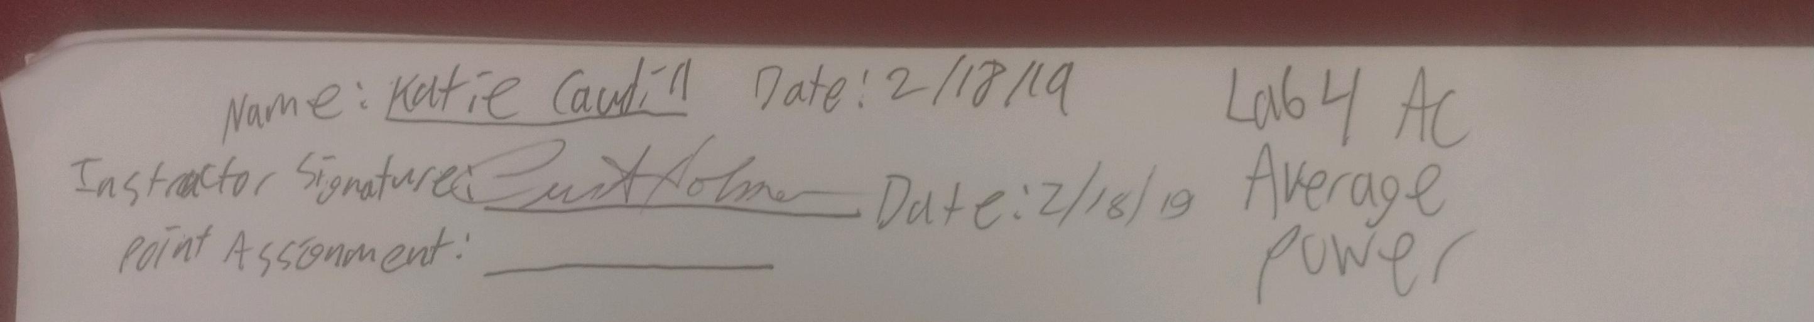

Purpose: To introduce the student to Average Power concepts in AC circuits. The student will compute and measure DC and AC average power for a resistor. In addition, the student will demonstrate that the average power for a capacitor and inductor is zero, even though current is flowing to the capacitor and inductor.

SAFETY CAUTION: This laboratory requires 120V in all experiments. You should treat this voltage level respectfully. Never handle a conductor terminal with 120V exposed. Do not lean on the equipment. Do not remove a conductor unless power is removed from the LabVolt unit through the proper disconnect. Do not perform any type of wiring connection to the circuit unless power is removed from the LabVolt unit. Always verify that power is off by observation and measurement. Students must always have supervision from an experienced instructor or laboratory technician when working with the LabVOLT equipment.

Background: The average power in a DC circuit is dependent on the magnitude of the voltage and current. The relationship is a simple product, P=VI. Other relationships that are frequently used to calculate average power are the following formulas:

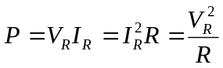

In an AC circuit, there are a few steps required to get to these simple relationships, but the relationships hold for AC circuits as well; however, the voltage and current are not peak AC values. The current and voltage used to compute average power in an AC circuit are RMS (root-mean-squared) values. The unit for Average power is Watt or W.

Fundamentally, the RMS value of a voltage source is simply the value of an AC waveform that produces the same average power as a DC source. For a resistive circuit, it is easy to prove that a 120VAC source provides the same average power as a 120V DC source.

Where other circuit elements are applied, i.e., the capacitor and inductor, the average power is zero. These devices are energy storage devices as opposed to energy consuming devices, so no average power is consumed by the capacitor and inductor. The power for a capacitor or inductor is known as reactive power, which does no meaningful work. This power is used to store and release energy as opposed to consuming the energy in the form of heat as a resistor. The capacitor and inductor power is known as Reactive Power and the unit is Volt-Ampere-Reactive, or VAR for short. Reactive Power is delivered to a device during the positive cycle of the power source and returned to the power source during the negative cycle of the power source. Since power is flowing to and from the reactive device, the reactive power must be considered when sizing equipment, protective devices, and conductors in an AC circuit.
To calculate Reactive Power, the following formulas are used
according to the type of energy storage device:
Capacitor: 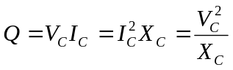, where V_{C} is the capacitor voltage, I_{C} is the capacitor current, and X_{C} is the capacitive reactance;
Inductor: 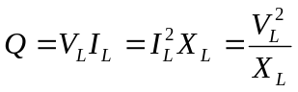 where V_{L} is the inductor voltage, I_{L} is the inductor current, and X_{L} is the inductive reactance.

When resistors and reactive elements are combined in the same circuit, both Average Power and Reactive Power will flow. The combination of Average and Reactive Power is known as Apparent Power given in units of Volt-Ampere or VA. The Apparent Power is represented by the letter S and can be calculated from 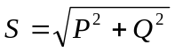.
Another important AC power parameter is the Power Factor. The Power Factor is simply the ratio of P and S, 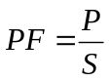. In most electrical distribution systems, the power factor should be kept to above 95%. The Average Power in an electrical system is a parameter that is always present as it is the power that does real work. (It is sometimes referred to as Real or True Power). The reactive power on the other hand, is a form of power that is easy to manage. The phase angle of capacitive power is 180º out of phase with the phase angle of inductive power, which presents an opportunity to reduce or cancel one another. For an inductive circuit, the power factor can be improved by adding capacitance. The additional capacitance will reduce the inductive reactance, and therefore, decrease the value of Apparent Power, S. Since the average power (P) doesn’t change, but the value of the Apparent power decreased, clearly, one can see from the power factor equation () that the Power Factor will rise. Likewise, to reduce the amount of capacitive power, an inductor can be introduced to the circuit, resulting in the same Power Factor increase.

Procedure: 1. (10%) For a 300Ω resistor connected to a 120V DC source,
calculate the average power and record the results in the table below. For a 300Ω resistor connected to a 120V, 60Hz, AC source, calculate the average power and record the results in the table below.

Table #1 – DC and AC Power Calculations
Type | Power (W)
DC | 48 W
AC | 48 W

2. (10%) Using the LabVolt Electrical Systems Unit:
DC Resistive Load
- Turn ON the power source to the LabVolt Unit.
- Set the DC adjustable supply to 120VDC.
- Turn OFF the power source to the LabVolt Unit.
- Connect the 120VDC power source to an ammeter, a voltmeter, and a 300Ω resistor using the LabVolt equipment (see figure #2).
- An instructor or laboratory technician must verify the circuit connections before continuing.
- Turn ON the power source to the LabVolt Unit.
- Record the voltage, current, and power measurements.

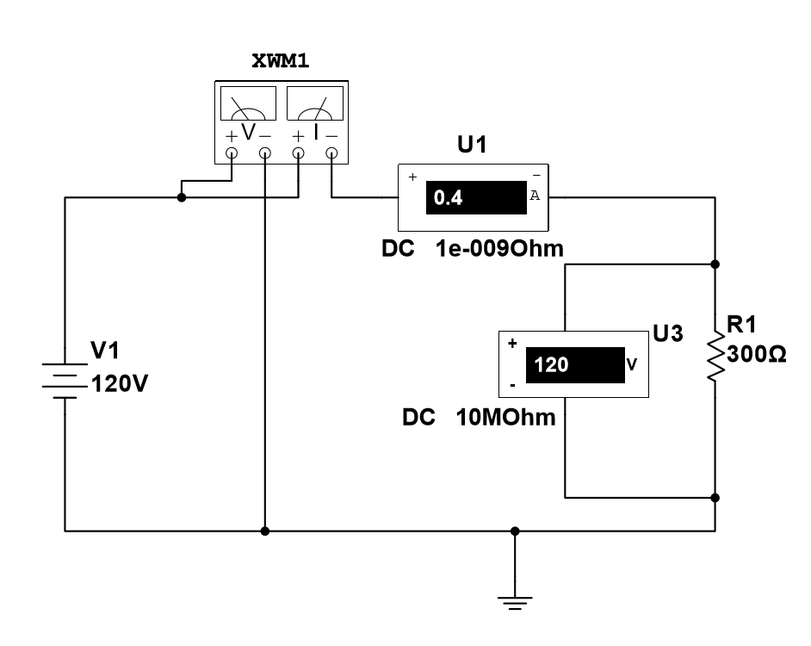
Figure #2 – DC Circuit Configuration

Table #2 – DC Resistive Power Measurements
Load | Voltage (V) | Current (A) | Power (W)
300Ω | 120 V | 410 mA | 49 W

- (10%) Using the LabVolt Electrical Systems Unit:
AC Resistive Load
- Turn ON the power source to the LabVolt Unit.
- Set the AC adjustable supply to 120VAC.
- Turn OFF the power source to the LabVolt Unit.
- Connect the 120VAC power source to a wattmeter, an ammeter, a voltmeter, and a 300Ω resistor using the LabVolt equipment (see figure #3).
- An instructor or laboratory technician must verify the circuit connections before continuing.
- Turn ON the power source to the LabVolt Unit.
- Record the voltage, current, and power measurements.

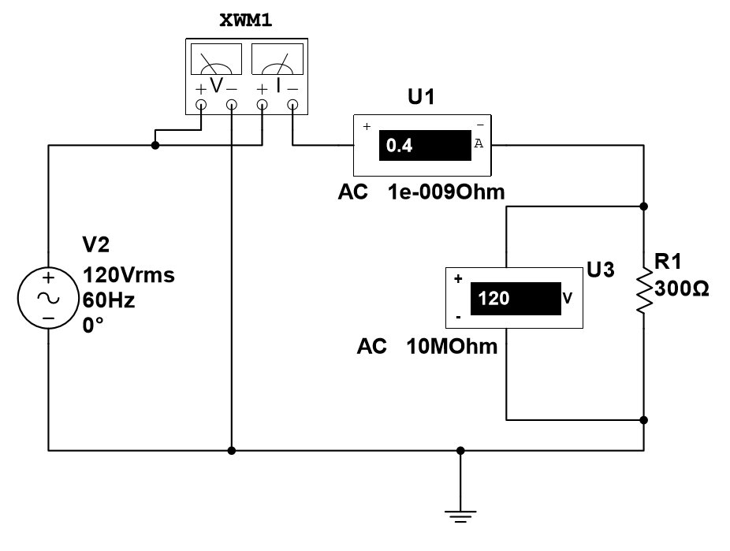
Figure #3: AC Resistive Circuit Configuration

Table #3 – AC Resistive Power Measurements

Load | Voltage (V) | Current (A) | Power (W)
300Ω | 120 V | 400 mA | 49 W

- (10%) Using the LabVolt Electrical Systems Unit:
AC Inductive Load
- Turn ON the power source to the LabVolt Unit.
- Set the AC adjustable supply to 120VAC.
- Turn OFF the power source to the LabVolt Unit.
- Connect the 120VAC power source to a wattmeter, an ammeter, a voltmeter, and a 800mH inductor using the LabVolt equipment (see figure #4).
- An instructor or laboratory technician must verify the circuit connections before continuing.
- Turn ON the power source to the LabVolt Unit.
- Record the voltage, current, and power measurements.

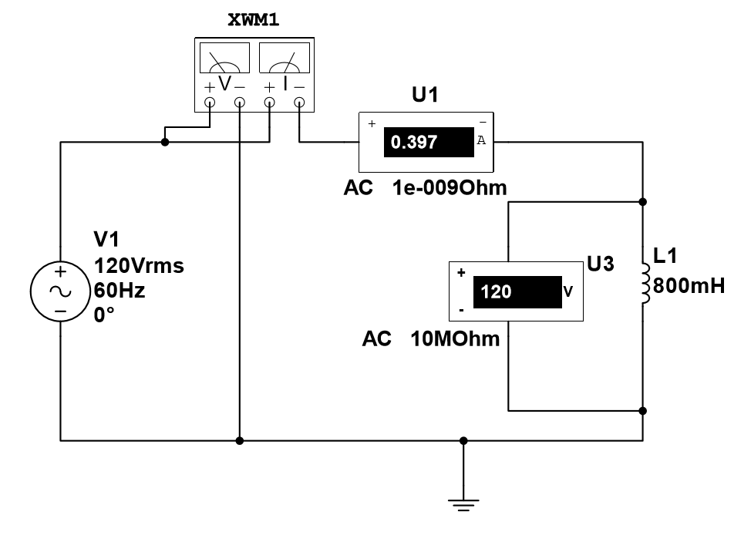
Figure #4: AC Inductive Circuit Configuration

Table #4 – AC Inductive Power Measurements

Load | Voltage (V) | Current (A) | Power (W)
800mH | 120 V | 405 mA | 0W

- (10%) Using the LabVolt Electrical Systems Unit:
AC Capacitive Load
- Turn ON the power source to the LabVolt Unit.
- Set the AC adjustable supply to 120VAC.
- Turn OFF the power source to the LabVolt Unit.
- Connect the 120VAC power source to a wattmeter, an ammeter, a voltmeter, and a 8.8 μF capacitor using the LabVolt equipment (see figure #5).
- An instructor or laboratory technician must verify the circuit connections before continuing.
- Turn ON the power source to the LabVolt Unit.
- Record the voltage, current, and power measurements.

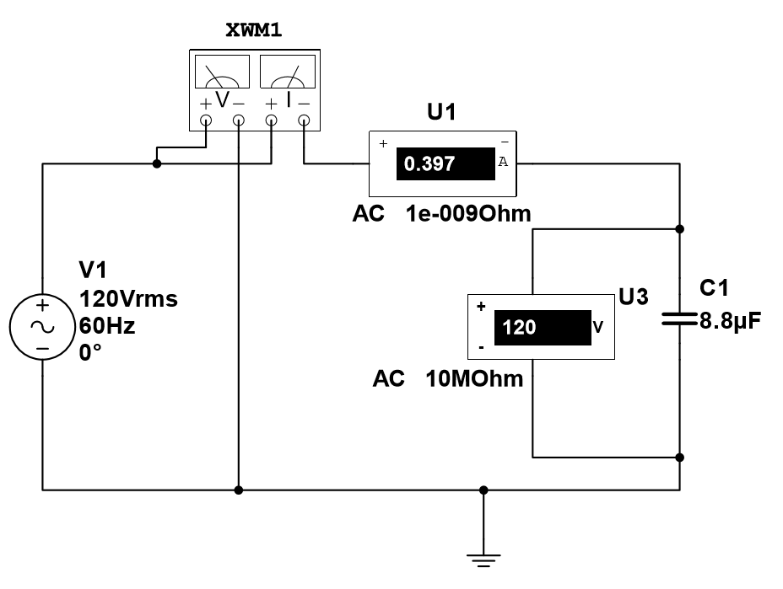
Figure #5: AC Capacitive Circuit Configuration

Table #5 – AC Capacitive Power Measurements

Load | Voltage (V) | Current (A) | Power (W)
800mH | 120 V | 395 mA | 0 W

- (10%) Using the LabVolt Electrical Systems Unit:
Power Factor
- Turn ON the power source to the LabVolt Unit.
- Set the AC adjustable supply to 120VAC.
- Turn OFF the power source to the LabVolt Unit.
- Connect the 120VAC power source to a wattmeter, an ammeter, a voltmeter, a 300Ω resistor in series with a 800mH inductor using the LabVolt equipment (see figure #6).
- An instructor or laboratory technician must verify the circuit connections before continuing.
- Turn ON the power source to the LabVolt Unit.
- Record the voltage, current, and power measurements.
- Using the measured data, calculate the Apparent Power and Power Factor.
- Repeat a-h for the circuit in figure #7 with includes the addition of a 4.4μF capacitor.

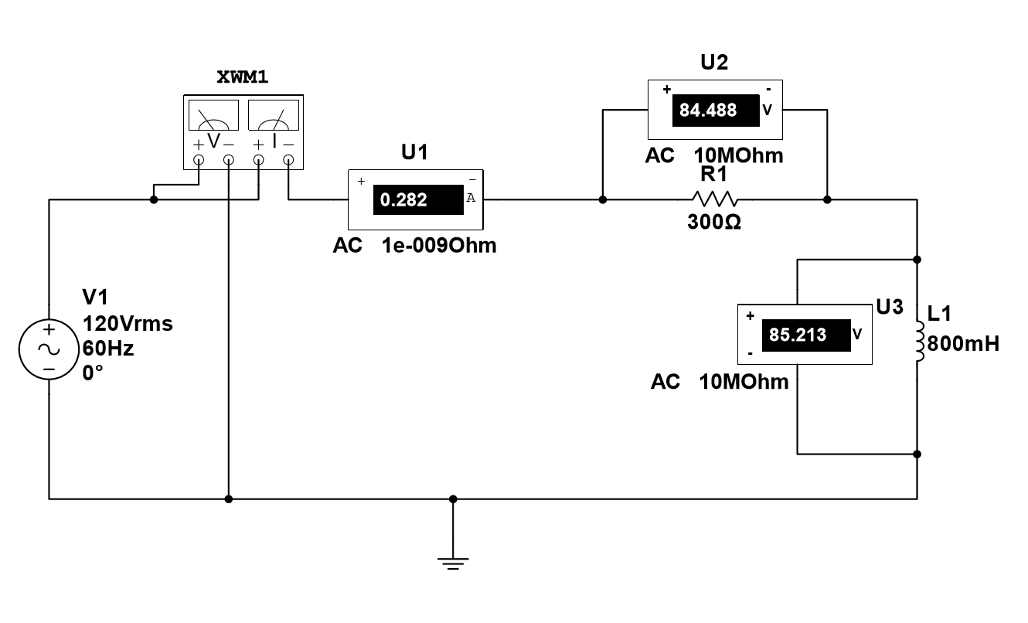
Figure 6: AC Resistor and Inductor Circuit and Measurement Arrangement

Table #6 – AC Capacitive Power Measurements

Load | Resistor Voltage (V) | Inductor  Voltage  (V) | Capacitor  Voltage  (V) | Current (A) | Average  Power (W) | Apparent  Power  (VA)  S=120V*I | PF  P/S
RL | 82 V | 84 V | ----------- | 280 mA | 25 W | 33.6 | 744
RLC | 82 V | 84 V | 120 V | 200 mA | 25 W | 24 | 1.04

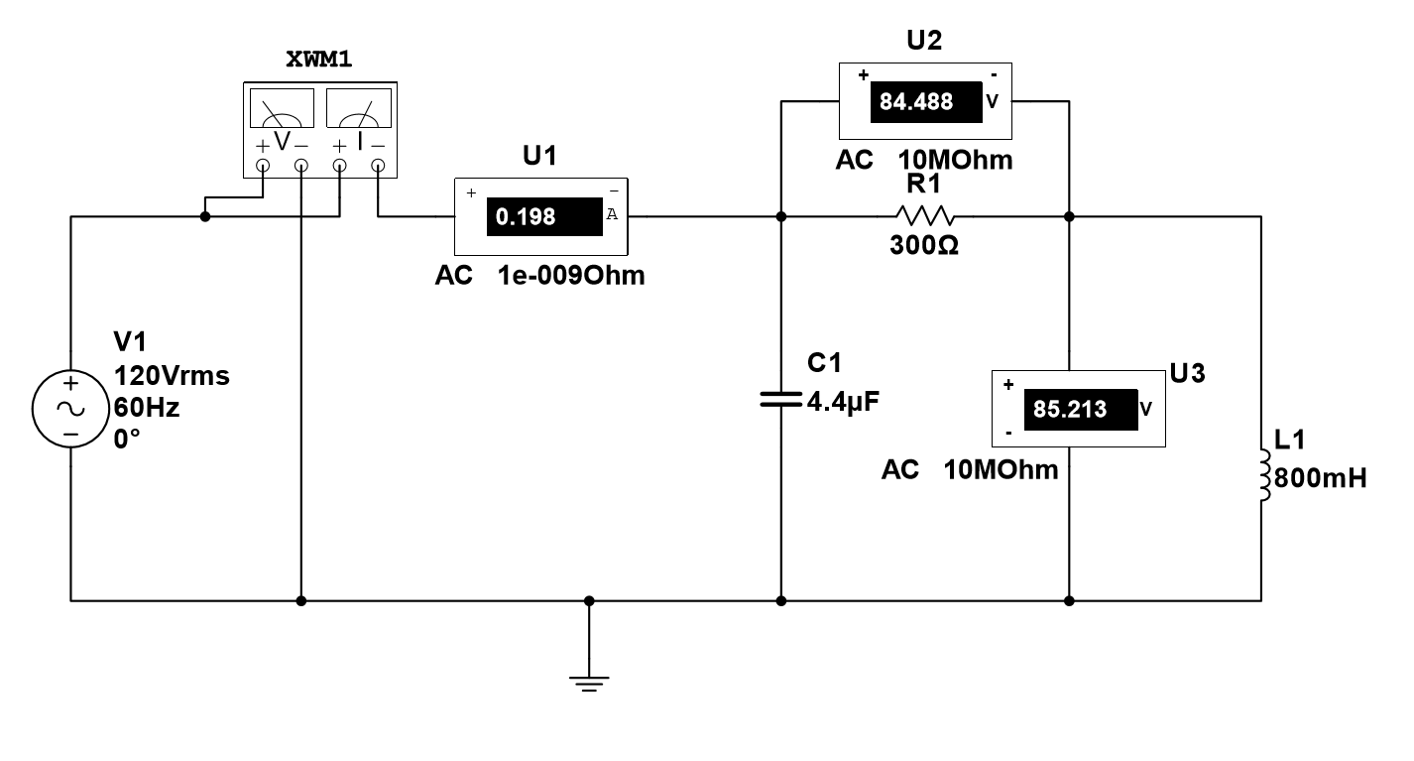
Figure 7: AC Resistor, Inductor, and Capacitor Circuit and Measurement Arrangement
Questions: (40%)
- Review the data in Table #2 & 3. Compare the two power measurements between the DC and AC resistive load circuits. What did you observe with the average power? Explain the observation.
They were the same

- Compare the measured DC and AC power from Tables 2 & 3 to those values calculated in Table #1. Do these values agree? What is the percent error:
Error = |Calculated-Measured|*100/Calculated
2.08%

- Review the measured average power for the capacitor and inductor Table #4 & 5. The values should be zero. Review the current flow in each circuit and identify the current values. (there will be current values.) Explain why there is no average power while current is flowing through the elements.
Capacitors and inductors do not use energy

- For the data collected in Table #6, compare the average power of the RL circuit to that in the RLC circuit. Did the Average Power change? Explain the observation.
No because only a capacitor was added

- For the data collected in Table #6, compare the source current of the RL circuit to that in the RLC circuit. Did the current change? Explain the observation.
Yes by 80 mA. The current changed because the capacitor was added.

- For the data collected in Table #6, compare the average power of the RL circuit to that in the RLC circuit. Explain why the power factor increased when a capacitor was added.
The power factor decreased because the current decreased

